Network Layers

Tatu Bogdan Gr. 3.1

1. 2 Extranet access users – EMAG





3. 5 Protocols

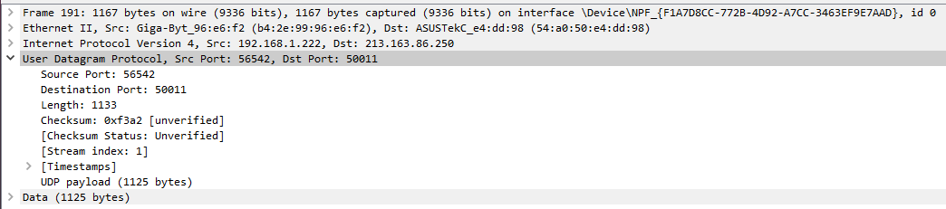

UDP: User Datagram Protocol

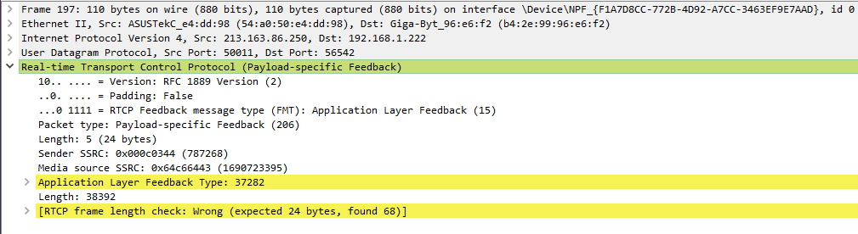

RTCP: Real-time Transport Control Protocol

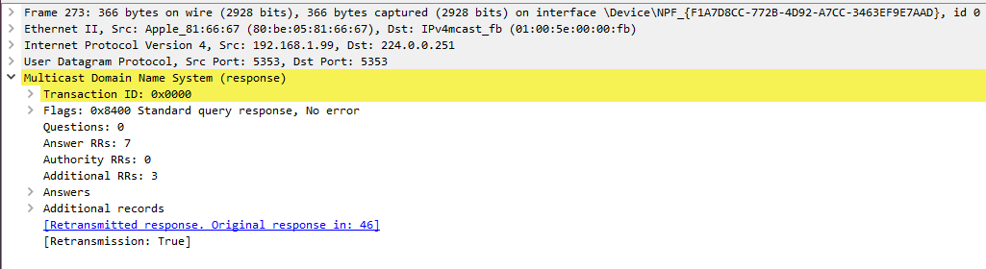

MDNS: Multicast Domain Name System

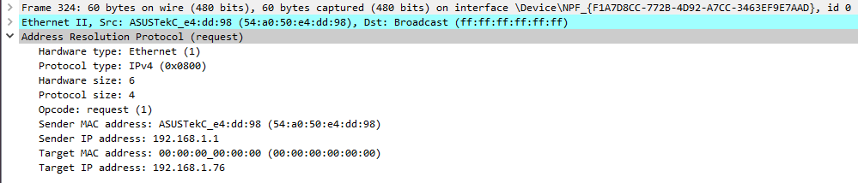

ARP: Address Resolution Protocol

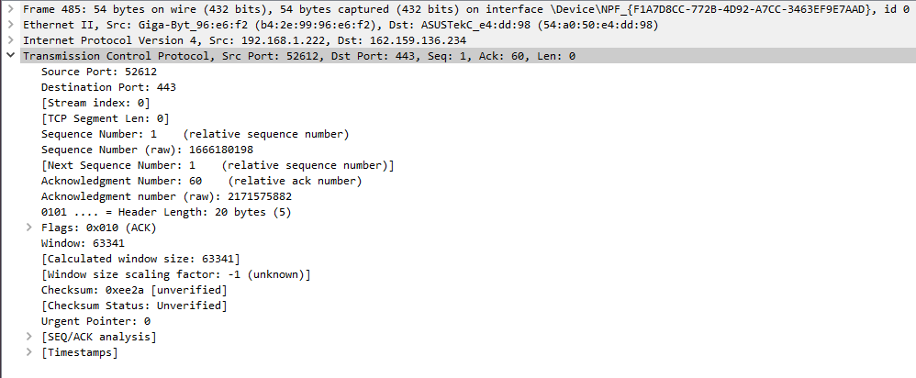

TCP: Transmission Control Protocol

4. Frame 720

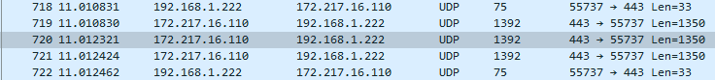

Start acquisition time: 11.012321s from start

5. Frame 180

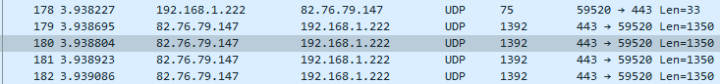

Frame size: 1392 bytes

6. Resolve MAC address setting

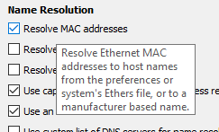

With:



Without:



Shows the manufacturer/vendor/host names based on the first 3 bytes of the MAC address